05 January 2026
NAME: ZAINAB INUWA | Age: 20y | Sex: F | Ref No:00010
Clinical Details: OBS
OBS REPORT
Maternal Survey:
Internal Os is closed.
Adnexa appears unremarkable.
Foetal Survey: -
- Sonogram revealed SINGLE intrauterine foetus.
- Presentation : BREECH at the moment
- Placenta Location : ANTERIOR
- Amniotic fluid : ADEQUATE
- Cardiac activity : PRESENT AND REGULAR

Biometry:
- Gestation age based on BPD, and FL is (GA): 24 weeks 01 day(s)
- Expected date of delivery by USG DD) : 27/04/2026 (±2 weeks)
- Foetal weight : 730 g
- Gender : (NOT SEEN)
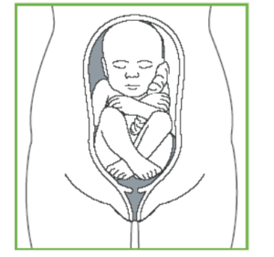
IMPRESSION: Single live intrauterine foetus at 24 weeks 01 day(s).
Normal abdomino-pelvic scan

Ultrasound Specialist

